**STUDY THE BANANA PEEL FIBRE 3D PRINTING FILAMENT WITH POLYMER COMPOSITES**

**A PROJECT REPORT**

***Submitted by***

**SATHIYANARAYANAN N (211419114268)**

**ALIN REKEESH V (211419114028)**

**KUMARAN R (211419114153)**

**MYTHRAYAN K P (211419114176)**

***In partial fulfillment for the award of the degree***

**of**

**BACHELOR OF ENGINEERING**

**In**

**MECHANICAL ENGINEERING**



**PANIMALAR ENGINEERING COLLEGE,CHENNAI**

**(An Autonomous Institution,Affiliated to Anna University,Chennai)**

**APRIL-2023**

**PANIMALAR ENGINEERING COLLEGE,CHENNAI**

**(An Autonomous Institution,Affiliated to Anna University,Chennai)**

**BONAFIDE CERTIFICATE**

Certified that this project report **“STUDY THE BANANA PEEL FIBRE 3D PRINTING FILAMENT WITH POLYMER COMPOSITES”** is the bonafide work

**SATHIYANARAYANAN N (211419114268)**

**ALIN REKEESH V (211419114028)**

**KUMARAN R (211419114153)**

**MYTHRYAN K P (211419114176**)

Who carried out the design and fabrication projectwork under my supervision.

**SIGNATURE SIGNATURE**

**Dr.L.KARTHIKEYANM.E,M.B.A,Ph.D MR.I. JOHN SOLOMON**

**PROFESSOR& HEAD ASST PROFFESOR**

Dept.of Mechanical Engineering Dept.of.Mechanical Engineering

Panimalar Engineering College Panimalar Engineering College

Bangalore trunk road , Bangalore trunk road ,

Ponamallae, Chennai -600123 Ponamallae, Chennai -600123

submitted for Anna university project Viva-voce held on…….during the year……

**INTERNAL EXAMINER EXTERNALEXAMINER**

**ACKNOWLEDGEMENT**

At the outset we would like to express our gratitude to our beloved respected Chairman**, Dr.Jeppiaar**, Our beloved correspondent and Secretary **Mr.P.Chinnadurai M.A., M.Phil., Ph.D.,** and our esteemed director for their support.

We would like to express thanks to our Principal, Dr. K. Mani M.E., Ph.D., for having extended his guidance and cooperation.

We would also like to thank our Head of the Department, **Dr.L.Karthikeyan M.E., Ph.D.,** professor, Department of Mechanical Engineering for his encouragement.

Personally we thank **Mr. I. JOHN SOLOMON** Asst Professor in Departmentof Mechanical Engineering for the persistent motivation and support for this project, who at all times was the mentor of germination of the project from a small idea.

We express our thanks to the project coordinator **Mr. GUNASEKARAN** Asst professor in Department of Mechanical Engineering for the Valuable suggestions from time to time at every stage of our project.

Finally, we would like to take this opportunity to thank our family members, friends, well-wishers who have helped us for the successful completion of our project.

We also take the opportunity to thanks all faculty and non-teaching staff membersto our department for their timely guidance to complete our project.

**TABLE OF CONTENT**

|  |  |  |
| --- | --- | --- |
| **CHAPTER NO.** | **TITLE** | **PAGE NO.** |
|  | **ABSTRACT** |  |
|  | **LIST OF FIGURES** |  |
|  | **LIST OF TABLES** |  |
| **1.** | **INTRODUCTION** | **1** |
|  | 1.1 INTRODUCTION TO ADDITIVE MANUFACTURING | **1** |
|  | 1.2TYPRS OF 3D PRINTERS | **2** |
|  | 1.2.1 STEREOLITHOGRAPHY | **2** |
|  | 1.2.2 MATERIAL JETTING | **3** |
|  | 1.2.3 BINDER JETTING | **4** |
|  | 1.2.4 FUSED DEPOSITION MODELLING | **5** |
|  | 1.2.5 SHEET METAL LAMINATION | **6** |
|  | 1.2.6 POWDER BED FUSION | **7** |
|  | 1.2.7 DIRECT ENERGY DEPOSITION | **8** |
|  | 1.3 TYPES OF FILAMENT MATERIALS | **9** |
|  | 1.3.1 PLA | **9** |
|  | 1.3.2 ABS | **10** |
|  | 1.3.3 WOOD FILAMENT | **12** |
|  | 1.3.4 NYLON | **13** |
|  | 1.3.5 GLOW IN DARK FILAMENT | **14** |
|  | 1.3.6 PETT FILAMENT | **15** |
|  | 1.3.7 MAGNETIC IRON FILAMENT | 16 |
| **2.** | **LITERATURE SURVEY** | 17-20 |
| **3.** | **METHODOLOGY & SELECTION OF FIBRES** | 21 |
|  | 3.1 METHODOLOGY | **21** |
|  | 3.2 FIBRES | 22 |
|  | 3.2.1 PROPERTIES | 22 |
|  | 3.2 TYPES OF FIBRES | **23** |
|  | 3.2.1 NATURAL FIBRES | **23** |
|  | 3.2.1.1 COTTON FIBRE | **24** |
|  | 3.2.1.2 FLAX FIBRE | 26 |
|  | 3.2.1.3 JUTE FIBRE | 27 |
|  | 3.2.1.4 BAMBOO FIBRE | 29 |
|  | 3.2.1.5 BANANA FIBRE | 31 |
|  | 3.2.2 SYNTHETIC FIBRE | 31 |
|  | 3.2.2.1 TYPES OF SYNTHETIC FIBRE | 32 |
| **4** | **PREPARATION OF FILAMENT** |  |
|  | 4.1 PREPARATION PROCESS | 36-37 |
|  | 4.2 TYPES OF BANANA FIBRE | 38 |
|  | 4.3 FIBRE IN POWDER STATE | 39 |
|  | 4.4 ADVANTAGE & DISADVANTAGE OF USING BANANA FIBRE | 40 |
|  | 4.4 MATERIAL USED | 42 |
|  | 4.4.1 PLA | 42 |
|  | 4.4.2 JUTE FIBRE | 42 |
|  | 4.5 MAIN MOTIVE TO PREPARE A FILAMENT WITH NATURAL FIBRE | 42 |
|  | 4.6 PREPARATION OF FILAMENT | 43 |
| **5** | **CONCLUSION** | 45-49 |
| **6** | **REFERENCE** | 50 |

**LIST OF FIGURES**

|  |  |  |
| --- | --- | --- |
| **FIG.NO** | **DESCRIPTION** | **PAGE.NO** |
| 1.1 | HISTORY OF ADDITIVE MANUFACTURING | 2 |
| 1.1 | TYPES OF 3D PRINTING | 2 |
| 1.1 | SCHEMATIC DIAGRAM OF STEREOLITHOGRAPHY | 2 |
| 1.2 | SCHEMATIC DIAGRAM OF MATERIAL JETTING | 3 |
| 1.3 | SCHEMATIC DIAGRAM OF BINDER JETTING | 4 |
| 1.4 | SCHEMATIC DIAGRAM OF FUSED DEPOSITION MODELLING | 5 |
| 1.5 | SCHEMATIC DIAGRAM OF SHEET LAMINATION | 6 |
| 1.6 | SCHEMATIC DIAGRAM OF POWDER BED FUSION | 7 |
| 1.7 | SCHEMATIC DIAGRAM OF DIRECT | 9 |
| 1.8 | FILAMENT OF PLA MATERIAL | 10 |
| 1.9 | ACYLONITRILE BUTADIENE STYRENE | 11 |
| 2.1 | WOOD FILAMENT | 12 |
| 2.2 | NYLON | 13 |
| 2.3 | GLOW IN DARK FILAMENT | 14 |
| 2.4 | PETT FILAMENT | 15 |
| 2.5 | MAGNETIC IRON FILAMENT | 16 |
| 3.1 | FIBRES LAYERED | 22 |
| 3.1.1 | FIBRES WEAVING | 23 |
| 3.2 | COTTON FIBRES | 25 |
| 3.3 | COTTON FIBRE COMES FROM COTTON SEED | 26 |
| 3.4 | FLAX SEED | 27 |
| 3.5 | FLAX FIBRE COMES FROM FLAX SEED | 27 |
| 3.6 | JUTE FIBRE | 28 |
| 3.7 | BAMBOO SEED | 30 |
| 3.8 | BAMBOO FIBRE MAKING PROCESS | 30 |
| 3.9 | BAMBOO FIBRE | 30 |
| 3.10 | BANANA SEED | 31 |
| 3.11 | BANANA FIBRE COMES FROM BANANA SEED | 31 |
| 3.12 | MADE WITH CARBON FIBRE | 34 |
| 3.13 | MADE WITH GLASS FIBRE | 35 |
| 4.1 | BANANA SHELL | 39 |
| 4.2 | BANANA POWDER PROCESSING | 39 |
| 4.3 | BALL BEARING | 39 |
| 4.4 | BANANA POWDER | 40 |
| 4.5 | SCHEMATIC DIAGRAM OF TWIN EXTRUDER | 43 |
| 4.6 | TWIN EXTRUDER | 44 |
| 4.7 | FILAMENT AFTER PREPARED WITH NATURAL FIBRE AND PLA | 44 |
| 5.1 | FILAMENT IS GETTING STUCK | 45 |
| 5.2 | CLOGGED EXTRUDER | 46 |
| 5.3 | VERY LOW LAYER HEIGHT | 47 |
| 5.4 | VERY LOW LAYER HEIGHT | 47 |
| 5.5 | INCORRECT EXTRUSION WIDTH | 48 |
| 5.6 | POOR QUALITY FILAMANT | 48 |
| 5.7 | MECHANICAL EXTRUDER ISSUES | 49 |

**LIST OF TABLES**

|  |  |  |
| --- | --- | --- |
| **TABLE NO.** | **DESCRIPTION** | **PAGE NO** |
| 4.1 | FIBRES TENSILE STRENGTH AND MELTING TEMPERATURE | 41 |

**ABSTRACT**

In Industry, many components are manufactured in Additive Machining. Butthe materials for AM are mostly Polymers. Polymer and Polymer Composite are mostly made up of Non Biodegradable and it may leads the Environmental Problems Most of the Polymer filaments are fabricated by the Extruder Process So our project of main themes is to reduce the non-Biodegradable components.

A method of manufacturing known as ‘Additive manufacturing’, due to the fact that instead of removing material to create a part, the process adds material in successive patterns to create the desired shape. Main areas of use. Prototyping Specialized parts – aerospace, military, biomedical engineering, dental Hobbies and home use Future applications– medical (body parts), buildings and cars 3D

Printing uses software that slices the 3D model into layers (0.01mm thick or less in most cases). Each layer is then traced onto the build plate by the printer, once the pattern is completed, the build plate is lowered and the next layer is added on top of the previous one.

**CHAPTER-1**

**INTRODUCTION**

**1.1 ADDITIVE MANUFACTURING**

Additive manufacturing is the process of creating an object by building it one layer at a time. It is the opposite of subtractive manufacturing, in which an object is created by cutting away at a solid block of material until the final product is complete. Another Way it is defined as the process of creating a solid object from a 3D model using 3D printers. In AM, the material, or filament, is added one layer at a time and a fusing application, such as a heated printhead or laser, is used to bind the layers. This results in a 3D-printed object. Other Names for Additive Manufacturing are 3D printing, Rapid Prototyping, Direct Digital Manufacturing etc AM involves several steps that move from the virtual CAD description to the physical resultant part. Different products will involve AM in different ways and to different degrees. Small, relatively simple products may only make use of AM for visualization models, while larger, more complex products with greater engineering content may involve AM during numerous stages and iterations throughout the development process. Furthermore, the early stages of the product development process may only require rough parts, with AM being used because of the speed at which they can be fabricated.

At later stages of the process, parts may require careful cleaning and post-processing (including sanding, surface preparation, and painting) before they are used, with AM being useful here because of the complexity of form that can be created without considering tooling. AM Mainly classified into three types of Raw Materials they are Solids, Liquid and Gaseous

**1.2 TYPES OF 3D PRINTING**

**1.2.1 STEREOLITHOGRAPHY (SLA/VAT)**

Stereolithography (FIG:1.2.1) – more commonly referred to as SLA 3D printing – is one of the most popular and widespread techniques in the world of additive manufacturing. It works by using a high-powered laser to harden liquid resin that is contained in a reservoir to create the desired 3D shape. In a nutshell, this process converts photosensitive liquid into 3D solid plastics in a layer-by-layer fashion using a low-power laser and photopolymerization.

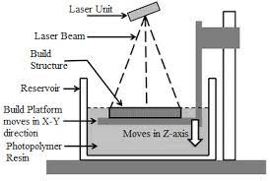

Figure 1.1 Stereolithography (SLA) Machine

SLA is one of three primary technologies adopted in 3D printing, together with fused deposition modeling (FDM) and selective laser sintering (SLS). It belongs to the resin 3D printing category. A similar technique that is usually grouped with SLA is called digital light processing (DLP). It represents a sort of evolution of the SLA process, using a projector screen instead of a laser. Stereolithography 3D printing in particular has undergone significant changes. Traditionally, SLA 3D printers have been monolithic and cost-prohibitive, requiring skilled technicians and costly service contracts. Today,

small format desktop printers produce industrial-quality output, at substantially more affordable price points and with unmatched versatility.Material manufacturers have created innovative SLA resin formulations with a wide range of optical, mechanical, and thermal properties to match those of standard, engineering, and industrial thermoplastics.

**1.2.2 MATERIAL JETTING(MJ)**

Material Jetting (MJ) (FIG:1.2) is an additive manufacturing process that operates in a similar fashion to 2D printers. In material jetting, a printhead (similar to the printheads used for standard inkjet printing) dispenses droplets of a photosensitive material that solidifies under ultraviolet (UV) light, building a part layer-by-layer. The materials used in MJ are thermoset photopolymers (acrylics) that come in a liquid form.

MJ 3D Printing creates parts of high dimensional accuracy with a very smooth surface finish. Multi-material printing and a wide range of materials (such as ABS-like, rubber-like and fully transparent materials) are available in Material Jetting. These characteristics make MJ a very attractive option for both visual prototypes and tooling manufacturing.

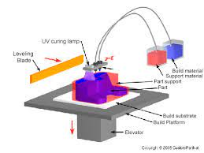

Figure 1.2 Material Jetting Machine

A variation of the MJ process uses Drop-On-Demand (DOD) printheads to dispense viscous liquids and create wax-like parts. DOD is used almost exclusively for manufacturing investment casting patterns though and for this reason we will not discuss it here further.

**1.2.3 BINDER JETTING(BJ)**

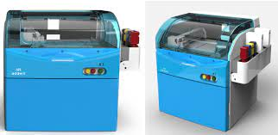Like all additive manufacturing techniques, binder jet 3D printing (FIG:1.2.3) builds up a 3D object layer by layer. But unlike other techniques, binder jetting does not require base plates or support structures. The technology was developed at MIT in 1993, and in 1996 ExOne was granted an exclusive patent to its use. While this patent has since expired, ExOne has more than 230 active and pending patents related to binder jetting. Binder jetting begins with the deposition of a very thin sheet of powder on what’s called the powder bed. The powder material can be metal, ceramic, sand or composite. ExOne currently has 22 certified powder materials for its printers.

Figure 1.3. Machine of Binder Jetting

Once the powder layer is deposited, the technique’s namesake—binder jetting—takes place. An inkjet, analogous to that found on a 2D printer, applies a small quantity of liquid binder to the powder in accordance with the print pattern. The binder acts as a glue between individual powder particles, locking them together to shape a single layer of the print. Then the powder bed moves down a notch, a new layer of powder is deposited, and the inkjet applies the next layer of binder. Layer by layer, the binder locks a 3D shape into place.

**1.2.4 FUSED DEPOSITION MODELLING (FDM)**

Figure 1.4. Fused Deposition Modeling Machine

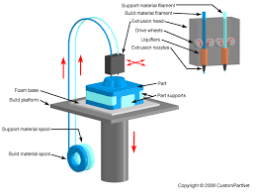(FDM) (FIG:1.4) is the most popular 3D printing method used today. You might not know the technical name, but if you see a 3D printer at work there is a good chance that it operates with this technology. After you send your graphic object design file to be printed, the FDM 3D printer starts to extrude a melted layer of thermoplastic filament (typically ABS or PLA) onto its build tray. The printer extrudes layer after layer of filament and the 3D object takes shape before your very eyes. Most models are created within a support structure printed onto a heated build plate with polyimide tape (such as Kapton) that is removed once the build is completed and cooled-down. This object building process is fun to watch, especially for kids and the young at heart. For this reason many 3D printer manufacturers leave the printing area open so you can see how the object is built up.

Even if you are not creating highly detailed objects you might still find that FDM cannot deliver the high-quality product you desire. Sometimes you might notice that the filament is extruded in a way that leaves lines between the printed layers. You can often get rid of these lines through sanding or using special finishing products but this is extra work. Although there are these limitations, the FDM method is still the ideal choice for most as it’s a great combination of ease of use, safe to use in nearly all environments, low equipment cost, and low cost of consumables.

**1.2.5 SHEET METAL LAMINATION**

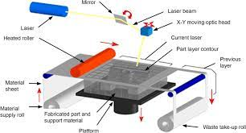Sheet Metal lamination (FIG:1.5) is one of the seven recognized 3D Printing methods. The process uses sheets of building material which are cut through laser or knife and the sheets are joined one after the other either by using an adhesive or by wielding the laser cut sheets together to form the 3D object. The process is also called ultrasonic additive manufacturing (UAM) in case the building

Figure 1.5 Sheet Metal Lamination

the material used is metal sheets. The variation of the process in which paper is used for making the 3D models is known by the name – Laminated Object Manufacturing (LOM). The apparatus for UAM variation of the sheet lamination process has a cylindrical sonotrode to which the material sheet is coiled. The sonotrode is rotated to feed the material sheet onto a building platform. If metal sheets are used as building material they are welded together before coiling over the sonotrode. Similarly in LOM variation of the process, paper sheets are glued together using an adhesive. The feed material sheet is cut by laser or knife on a layer by layer basis and passed to CNC machining for separating each model/part.  Each layer is laser cut and joined to the preceding layer by wielding (in case of UAM) or applying adhesive (in case of LOM). The Laminated Object Manufacturing involves an additional cross hatching process to remove the extra build ups. Sheet Lamination is a low temperature process and is used for making models for display. The process is quite useful for making visual models speedily at low cost. The process is however not suitable for making structural or functional models. That is why, even for prototyping, sheet lamination process has limited use. The process is usually used for making dummy models for demonstration purposes only.

**1.2.6 POWDER BED FUSION(PBF)**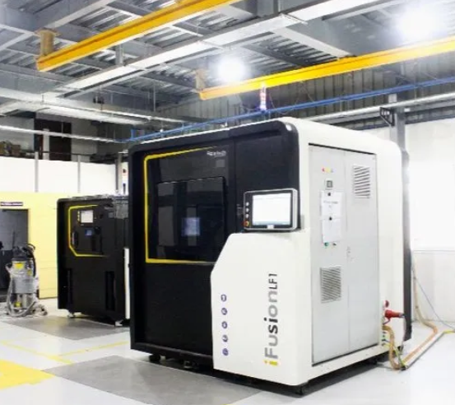

Figure 1.6 Powder bed Fusion Machine

Powder Bed Fusion (PBF) (FIG:1.6) 3D printing technology spawns products with precision. This 3D printing technique enables the manufacturing of a vast array of geometrically complex products using a heat source, mainly laser or electron beams, to fuse powder particles layer-by-layer, therefore forming a solid part. Manufacturers can benefit from substantial freedom of design considering that PBF presents several viable technologies and materials.SLS 3D printing technology originated in the late 1980’s at the University of Texas at Austin. Over the years, this technology has experienced remarkable advances. Basically, the process uses lasers to sinter, or coalesce, powdered material layer-by-layer to create a solid structure. The final product, rendered enveloped in loose powder, is then cleaned with brushes and pressurized air. The main materials used in the SLS 3D printing process include polyamide (Nylons), Alumide (a blend of gray aluminum powder and polyamide), and rubber-like materials. Nylons are strong and durable but do feature some flexibility, making them excellent for snap fits, brackets, clips, and spring features. Designers should take the susceptibility for shrinkage and warping of thin parts into consideration during the conceptual phase.

**1.2.7 DIRECT ENERGY DEPOSITION (DED)**

The DED (FIG:1.7 ) process begins with the creation of a 3D model using CAD software. This model is then sliced into layers with software to represent the layers that are required to create the finished workpiece. Directed Energy Deposition works by depositing material that has been melted onto a specified surface where it solidifies, fusing materials together to form a structure. DED machines typically use a nozzle that is mounted on a multi axis arm which can move in multiple directions, allowing for variable deposition. The process is typically performed within a controlled chamber with reduced oxygen levels. With electron beam-based systems the process is performed in a vacuum , while laser-based systems use a fully inert chamber when working with reactive metals. It is also possible to use a shielding gas to shroud the part and prevent contamination during metal 3D printing. DED uses a heat source to melt a powder or wire as it is deposited onto the surface of an object. While powder provides greater accuracy in deposition, wire is more efficient with regards to material use. The material is added layer-by-layer and solidifies from the melt pool to create new features. Layers are typically 0.25mm to 0.5mm thick. The cooling times for materials are very fast at around 1000-5000 °C per second. The cooling time affects the final grain structure although overlapping in the material can cause re-melting, which creates a uniform but alternating microstructure.  In most cases, the object remains in a fixed position while the arm moves to lay down the material. However, this can be reversed with the use of a platform, which moves while the arm remains 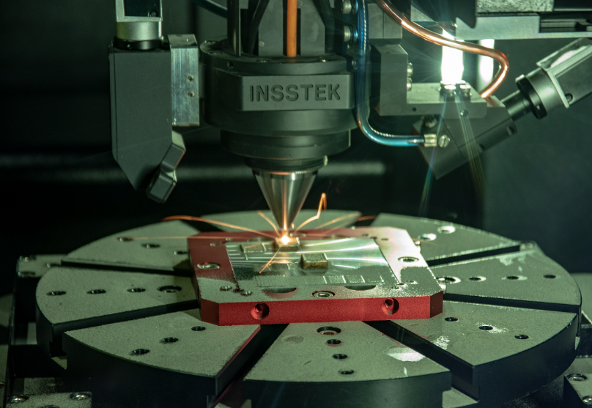stationary.

Figure 1.7. Direct Energy Deposition

Typically used to work on metal parts, this process can also be used with polymers and ceramics. Almost any weldable metal can be additively manufactured using DED including aluminium, inconel, niobium, stainless steel, tantalum, titanium and titanium alloys, and tungsten.

**1.3 TYPES OF FILAMENT MATERIALS**

**1.3.1 PLA**

Polylactic Acid (PLA) (FIG:1.8)filament is a recyclable, natural thermoplastic polyester that is derived from renewable resources such as corn starch or sugar cane. The filament is biodegradable under certain conditions with high heat capacity and high mechanical strength.This material is a thermoplastic aliphatic polyester and it is the primary natural raw material used in 3D printing. PLA is a fully biodegradable thermoplastic polymer consisting of renewable raw materials. Among all 3D printing materials, PLA is part of the most popular materials used for additive manufacturing for filament fabrication. PLA is a bioplastic, used in 3D printing using the [FDM](https://www.sculpteo.com/en/3d-printing/3d-printing-technologies/#fdm) (Fused Deposition Modeling) technology, and along with [ABS (Acrylonitrile Butadiene Styrene)](https://www.sculpteo.com/en/glossary/abs-definition/), this material is one of the standard materials for this technology.

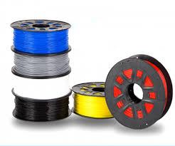

Figure 1.8. Filament of PLA materials

There is often a tendency to compare these plastic materials, as they are the two most common alternatives available for consumer printers. PLA plastic material is easy-to-use and offer some interesting mechanical properties.PLA material is printed using BigRep 3D printers and mainly used to manufacture big parts up to 1x1x1m.Even if this PLA material offers the opportunity to 3D print impressive big parts, please keep in mind that you will have to respect specific design guidelines to avoid any problem during the additive manufacturing process. Be sure to check the material design guidelines while creating your 3D file and before you send it for 3D Printing

**1.3.2 ABS**

ABS or Acrylonitrile Butadiene Styrene (FIG:1.3.2 ) is a part of the thermoplastic polymers family. It is one of the most popular plastics used today. It is also one of the first plastics being used for industrial 3D printing. ABS filament is widely used in most industries because it is easy to process, easily machined, sanded and glued. Today, ABS filament is commonly used in LEGO bricks and bicycle helmets. You can also find it in pipe systems, home appliances, toys, musical instruments, medical devices and many more. Moreover, it is a type of material that is frequently used in household 3D printing. ABS 3D printer filament has moderate strength and flexibility, and it features superior melt flow characteristics. ABS has a high heat tolerance, which allows it to withstand hot temperatures, but where it really shines is its durability. This filament is ideal for items that are frequently handled, dropped, or heated.The ABS filament has significant properties that make it a great option, such as its strength and the fact that it is lightweight while it can handle many different chemicals as well. ABS material is also recyclable, which means that it is better for the environment than some other plastics by causing less waste.As long as the [settings are right](https://www.cmac.com.au/blog/3d-printer-calibration-tuning-tips), you will get good results when using ABS filament. With this material, you can even print overhangs around 45ᵒ. This filament oozes and strings lesser compared to other filaments and give models smoother finish.ABS filament is one of the most popular and commonly used materials for 3D printing. It is a low-cost material that is ideal for producing tough and durable 3D parts. Aside from that, it is widely available in the market today. If you want to use ABS filament for your next 3D printing project, you can ask [a local 3D printing service provider to assist you](https://www.cmac.com.au/3d-design-printing/3d-printing-services-sydney). They can also provide services for your 3D printing needs such as 3D design and modelling service, 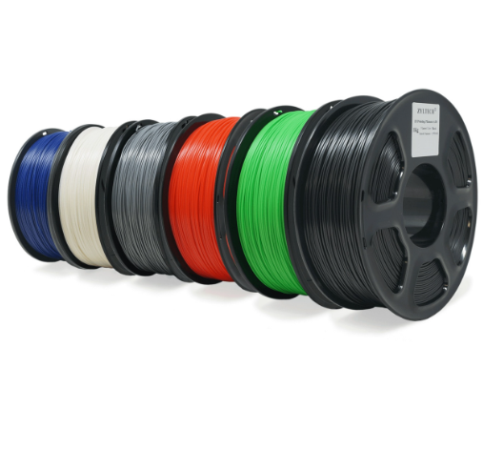custom 3D printing, industrial 3D printing and many more.

Figure 1.9 Acrylonitrile Butadiene Styrene

**1.3.3 WOOD FILAMENT**

With wood filament (FIG:2.1) you can print objects that look and feel like wood. Wood filament is not really just wood. In most cases, PLA is used as base material and wood fibers are added to the plastic giving it the look and feel of real wood. The printing temperature usually has to be reduced compared to normal PLA.Considering that wood filament is a composite material, it requires some tweaks to be done in the slicer settings to ensure reliable printing. For starters, it’s important to know that you shouldn’t be using [nozzles](https://all3dp.com/2/3d-printer-nozzle-size-material-what-to-know-which-to-buy/) smaller than 0.4 mm. Otherwise, the wood fibers from the filament can get stuck in the nozzle and be burnt, which results in a [clogged nozzle](https://all3dp.com/2/nozzle-clogging-vs-hot-end-oozing-what-s-the-difference/).

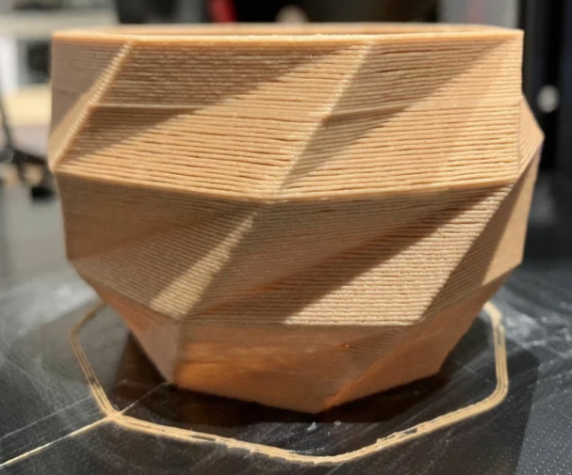Also related to the topic of nozzle clogging, make sure to remove the wood filament from the print head as soon as possible after the print finishes. If that’s not done, the remaining filament can get very hot if it stays in the nozzle and create a burning smell as well as a nozzle clog. It’s all about ensuring a good flow through the printhead while working with wood filament. Increasing [retraction speeds](https://all3dp.com/2/3d-printer-retraction-speed-what-does-it-mean/) helps reduce [stringing](https://all3dp.com/2/3d-print-stringing-easy-ways-to-prevent-it/) and nozzle clogging, while larger [layer heights](https://all3dp.com/2/3d-printer-layer-height-how-much-does-it-matter/) and faster [printing speeds](https://all3dp.com/2/3d-printing-speed-optimal-settings/) help ensure a steady flow during the printing process. With that in mind, let’s take a look at our choices for the best wood filaments currently available.

Figure 2.1 Wood Filament

**1.3.4 NYLON**

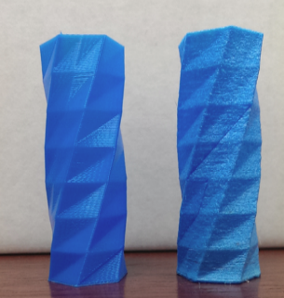Nylon(FIG: 2.2 ) 3D printing filament is a synthetic polymer known as a “thermoplastic,” which means that it softens upon heating, liquifies upon melting, and hardens when cooled – and is able to repeat these processes. In addition to FFF 3D printing, nylon is also used in other 3D printing processes, such as selective laser sintering (SLS), as well as more traditional processes like injection molding.Nylon 3D printing filament is strong, flexible, durable, and abrasion-resistant-resistant. It also has a low friction coefficient, which enables its wear and impact-resistant properties. When compared to other filaments, nylon is stronger but less stiff than both PLA and ABS. It is, however, much more flexible and features better impact resistance and chemical resistance, especially for applications where greases are commonly used. Nylon 3D printing filament also has some negative properties. It is prone to warping – a result of the material crystallizing. It is also hygroscopic, meaning it absorbs moisture from the air. This can lead to filament that is wet or damp, resulting in inconsistent final prints with lower mechanical properties. As such, nylon 3D printing filament should be stored in a dry place, such as the Ultimaker S5 Material Station. If your nylon filament should become wet, however, all is not lost. Moisture-sensitive filaments such as nylon, PVA, and TPU95A can be dried overnight (for 10-20 hours) and then used as normal.

Figure 2.2 Nylon

When printing nylon, you can print it alone with a single-extrusion 3D printer, or in combination with PVA and Breakaway material on 3D printers that allow for dual extrusion, such as the Ultimaker S5. When printed with a dual extruder, nylon can also be combined with TPU 95A or another color of nylon.

**1.3.5 GLOW IN DARK FILAMENT**

Glow-in-the-dark filament (FIG:2.3 ) is like any standard filament but with one key difference: It glows after being charged with light. This effect is achieved by additives such as strontium aluminate (and sometimes zinc sulfide and calcium sulfide), which absorb UV light and re-emit it as visible light The typical

Figure 2.3 Glow in Dark Filament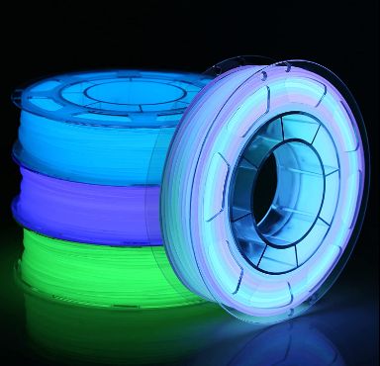

incandescent light bulb contains a thin wire (usually tungsten) called a filament that has a high electrical resistance. This filament gets very hot when an electric current passes through it. The intense temperature makes the filament glow brightly. Glow in the dark filaments are basically standard [ABS](https://3dinsider.com/what-is-abs/) or [PLA filaments](https://3dinsider.com/what-is-pla/) infused with a phosphorescent material. The most commonly used of these phosphorescent materials is strontium aluminate, although zinc sulfide and calcium sulfide are still used in some capacity. In a way, they are made in a very similar way to other composite materials such as carbon fiber filaments, magnetic filaments, and wood filaments.. Phosphorescent materials work by absorbing energy from ultraviolet radiation and re-emitting this energy in a slower and less intense manner. This is how glow in the dark toys and paint are charged by any normal light (indoor light or sunlight) and glow under darkness.

**1.3.6 PETT FILAMENT**

PETT stands for Polyethylene coTrimethylene Terephthalate (FIG:2.4 ). Compared to [PETG (glycol-enhanced PET)](https://3dinsider.com/petg-filament/), PETT has better optical properties and

Figure 2.4 PETT Filament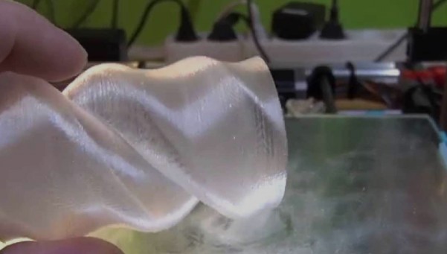

is slightly more rigid. While PETT is certainly far less popular than PETG, a company called Taulman has been quite successful in creating their own PETT line, which is branded as T-glase – short for “tough glass. ”Being an early adopter for this particular 3D printing filament, you will hardly find any other brand that sells PETT aside from Taulman. T-glase has become well-regarded for its enhanced strength and optical properties. As its name implies, the quality of prints made using T-glase approaches that of real glass. Right now, Taulman offers a huge variety of T-glase colors including clear, white, black, green, red, and blue. The recommended setting for printing temperature when working with PETT is somewhere in the range of 212 to 235 °C. Although PETT has minimal shrinkage and superior layer adhesion, a heated bed is still recommended to reduce the thermal shock as the heated filament hits the build platform. A setting of 50 to 75 °C. is recommended for the bed. You can print the PETT directly on a heated glass bed without any adhesion aid, but there’s nothing stopping you from applying a layer of Kapton tape on there. If a heated bed is not available, then printing PETT on a standard print bed is still possible, but we suggest applying a layer of glue stick on the bed. Since PETT is not prone to warping,

**1.3.7 MAGNETIC IRON FILAMENT**

Magnetic Iron Filament (FIG:2.5 ) is a Stainless-Steel PLA filament which can be polished or brushed for a brilliant metallic finish, or left unfinished for a cast metal look. The other is an extremely unique Magnetic Iron PLA. This has many of the same properties that traditional iron does, including the ability to attract magnets. On top of this, the iron may be oxidized, resulting in a unique rusty patina as a finish.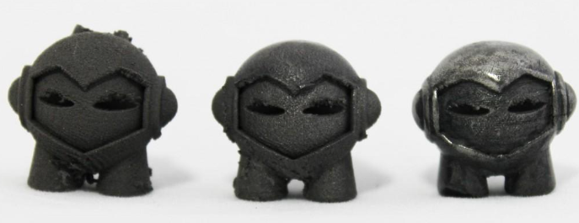

Figure 2.5 Magnetic iron Filament

It seems as though just over a year ago, we were pretty much limited to 3D printing with two types of plastic — ABS and PLA. Now there are many different options available which increase the possibilities of designs that can now be fabricated on an FFF/FDM 3D printer. The idea of being able to 3D print metal-like objects with an affordable desktop 3D printer means the designers are now provided with even more options to choose from when coming up with new unique 3D printed ideas.

**CHAPTER-2**

**LITERATURE SURVEY**

2.1 Salman Pervaiz Done 3d Printing of Fiber-Reinforced Plastic Composites Using Fused Deposition Modeling Composite materials are a combination of two or more types of materials used to enhance the mechanical and structural properties of engineering products. When fibers are mixed in the polymeric matrix, the composite material is known as fiber-reinforced polymer (FRP). FRP materials are widely used in structural applications related to defense, automotive, aerospace, and sports-based industries. These materials are used in producing lightweight components with high tensile strength and rigidity. The fiber component in fiber-reinforced polymers provides the desired strength-to-weight ratio; however, the polymer portion costs less, and the process of making the matrix is quite straightforward. There is a high demand in industrial sectors, such as defense and military, aerospace, automotive, biomedical and sports, to manufacture these fiber-reinforced polymers using 3D printing and additive manufacturing technologies.

2.2 RupakDua Done Applications of 3d-Printed Peek Via Fused Filament Fabrication, Polyether ether ketone (PEEK) is an organic polymer with potential applications in various fields and industries, including medical, chemical, aerospace, and electronics industries. PEEK polymer is obtained by step-growth polymerization of 4,4′-difluorobenzophenone (DFPB) and hydroquinone (HQ) conducted at high temperature in a polar solvent such as diphenylsulphone, giving them a backbone of ether and ketone molecules . PEEK is a highly durable polymer with an equal balance of a ketone group providing rigidity and an ether group providing flexibility to its structure. PEEK has a wide range of uses in the medical industry due to its excellent biocompatibility, radiolucency, chemical resistance, low density (1.32 g/cm3), and mechanical properties resembling human bone. PEEK competes with many metals and alloys, including titanium and aluminum that serve in manufacturing industries. Being lightweight and having excellent mechanical properties, PEEK has started being used in aerospace industries . Additionally, PEEK’s inertness makes it a viable material to construct reactors at the macro and micro levels . PEEK is also a suitable material for customizable parts, given that it is relatively inexpensive and can be transformed into unique structures through additive manufacturing .

2.3 Balwant Singh is mentioned in the Journal Polymer Matrix Composite in 3d Printing. 3d Printing is a set of advanced manufacturing techniques which facilitate layer by layer fabrication of customized products with intricate designs using wide selection of materials such as polymers, metals, ceramics, composites etc. 3D printing processes are becoming the need of the industry nowadays owing to their capability to manufacture complex structures with variable mechanical, electrical and thermal properties. In this paper an endeavour has been made to recognize the different Polymer Matrix Composite (PMC) materials used for the 3D printing through an extensive literature survey. Screw extrusion most popular technology as wide range of virgin thermoplastic polymers and PMCs can be used as raw material for 3D printing. This study disclose that researchers have primarily focussed on development of in-house Polymer Matrix Composite materials using variable composition, size and type of reinforcements and matrix. As a result, these materials exhibited variable mechanical, thermal, electrical and tribological properties. This paper also highlights different polymer processing techniques, methodology adopted and findings of recent studies executed to investigate the properties of polymer matrix composites. Moreover, applicability of material developed in each study has been indicated. It can be predicted that presence of 3d printed materials especially composite structures have ever increasing applications in various fields such as Biomedical, Aerospace, Military, Automobile and ornaments/jewellery. The pathways for potential researchers working in advancement of different polymer matrix composites in 3D printing have been highlighted.

2.4 R.SuryaTeja Done 3d Printing Of Complex Structures: Case Study Of Eiffel Tower “In today's Industry 4.0 generation, 3D printing is emerging as a viable tool, and additive manufacturing technologies play a key role in cost-effective manufacturing.” The benefits of using 3D printing for industrial applications include reduced material waste, ease of production, flexible design, reduced human involvement, minimal post-processing, and energy efficiency. Many of the world's most prominent scale model makers and architectural firms have already recognised the advantages of 3D printing. Additive manufacturing applications in architecture and construction, such as house construction, bridge construction, complex structures, and so on, have a strong and long-lasting life. ‘The primary objective of this research is to comprehend the process of 3D printing for complex structures. “This article provides a concise overview of the available 3D printing methods and technologies, along with their industrial applications”. The generic process chain of 3D printing, from the initial stage of CAD modelling, to the production of the final part with a typical example of an Eiffel tower is demonstrated. The challenges faced were also addressed.

2.5 NurulHusnaMohdYusoff Done Optimization Strategies And Emerging Application Of Functionalized 3d-Printed Materials In Water Treatment Advanced technologies such as additive manufacturing and providing affordable technology for the community to adopt. Recently, there has been a significant advancement in additive manufacturing for water treatment due to its inherent advantages of high printing resolution, rapid fabrication process with good control in pore structure and porosity, better energy efficiency, and excellent mechanical properties for regeneration and reusability of the device. Additionally, the use of surface functionalization, by chemical or physical means, to enhance the surface properties of 3D-printed parts has also recently garnered much attention . The combination of 3D printing and surface functionalization has been used on a large scale for industrial applicability to produce structures and components with unique physical and chemical properties. One of the promising applications is in the area of environmental and water treatment research.

**CHAPTER-3**

**METHODOLOGY & SELECTION OF FIBRES**

**3.1 METHODOLOGY**

**Select the suitable Natural fibre elements for 3D Printing filament**

**Mixing of Polymer Composite Material with Natural Fibre**

**Making the Filament Using Extruder Process**

**Preparing the Filament for 3D Printing**

**After preparing the Filament in 3D printing it have to be cooled**

**3.2 FIBRES**

Clothing is one of the three basic needs of humans apart from food and shelter. Since the prehistoric era, there has been constant change, advancements, and modifications in all these basic needs of human beings to make our lives comfortable and easy. Thus, clothing is another sector that has experienced a drastic advancement over the years. There are two types of fibres based on origin: natural and synthetic. Cotton, wool, and silk are natural fibres as they are directly extracted from plants and animals. At the same time, nylon, rayon, etc., are synthetic fibres as they are manmade fibres with several repeating units manufactured in laboratories by various chemical processes using petroleum products, also known as petrochemicals as raw materials.

* + 1. **PROPERTIES**

1. The word staple is associated with the dimension of the fiber, such as the length and diameter. It is an essential requirement because a fiber has to be long and fine enough for satisfactory use.
2. The fiber should also be strong enough to be spun into yarn which can ultimately be converted into durable fabrics. The strength of the textile fibers is very much influenced by the moisture in the atmosphere
3. The fiber must be elastic enough for easy production of yarn, so that it helps in weaving of the fabric. This elasticity property of the fiber makes the fabric become wrinkle resistant and helps to maintain their shape and size.
4. Uniformity is another property of fibers. Fibers of uniform dimensions spin better and make a smoother and uniform yarn.
5. The fibers (FIG:3.1.1& 3.1.2) must have good spinning quality. In order to have this quality, fibers must have cohesiveness as this prevents fiber slippage. Besides these essential properties, there are some other desirable properties like density or specific gravity, lustre, moisture regain, 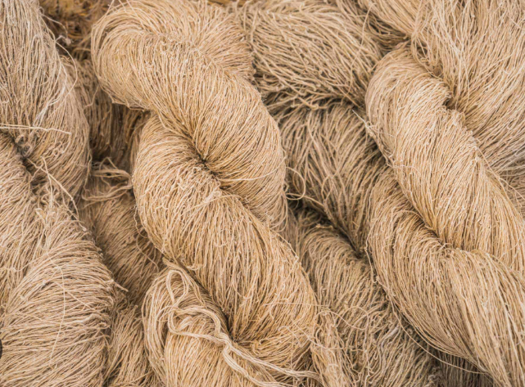flammability, felting, resistance to heat, alkalis, acids and bleaches etc.

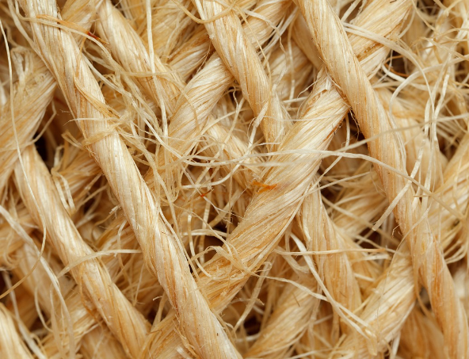Figures:3.1Fibres Layered

Figures:3.2Fibres Weaving

**3.2 TYPES OF FIBRES**

**3.2.1 NATURAL FIBRES**

Natural fibers or natural fibers  that are produced by [geological processes](https://en.wikipedia.org/wiki/Geology), or from the bodies of [plants](https://en.wikipedia.org/wiki/Plants) or [animals](https://en.wikipedia.org/wiki/Animals).  They can be used as a component of [composite](https://en.wikipedia.org/wiki/Composite_material) materials, where the orientation of fibers impacts the properties. Natural fibers can also be [matted](https://en.wikipedia.org/wiki/Felted) into sheets to make [paper](https://en.wikipedia.org/wiki/Paper) or [felt](https://en.wikipedia.org/wiki/Felt). The earliest evidence of humans using fibers is the discovery of [wool](https://en.wikipedia.org/wiki/Wool) and dyed [flax](https://en.wikipedia.org/wiki/Flax) fibers found in a prehistoric cave in the [Republic of Georgia](https://en.wikipedia.org/wiki/Georgia_(country)) that date back to 36,000 [BP](https://en.wikipedia.org/wiki/Before_Present). Natural fibers can be used for high-tech applications, such as [composite](https://en.wikipedia.org/wiki/Composite_material) parts for automobiles and medical supplies. Compared to composites reinforced with [glass fibers](https://en.wikipedia.org/wiki/Glass_fiber), composites with natural fibers have advantages such as lower density, better thermal insulation, and reduced skin irritation. Further, unlike glass fibers, natural fibers can be broken down by bacteria once they are no longer used. Natural fibers are good water absorbents and can be found in various textures. Cotton fibers made from the [cotton](https://en.wikipedia.org/wiki/Cotton) plant, for example, produce fabrics that are light in weight, soft in texture, and which can be made in various sizes and colors. Clothes made of natural fibers such as cotton are often preferred over clothing made of [synthetic fibers](https://en.wikipedia.org/wiki/Synthetic_fiber) by people living in hot and humid climates.

* + - 1. **COTTON FIBRE**

Cotton fibers (FIG:3.2) are natural hollow fibers; they are soft, cool, known as breathable fibers and absorbent. Cotton fibers can hold water 24–27 times their own weight. They are strong, dye absorbent and can stand up against abrasion wear and high temperature. In one word, cotton is comfortable. Since cotton wrinkles, mixing it with polyester or applying some permanent finish gives the proper properties to cotton garments. Cotton fibers are often blended with other fibers such as nylon, linen, wool, and polyester, to achieve the best properties of each fiber.Cottonfibres are anisotropic and have a complex morphological structure. They are single cell seed hair that grows around the seeds of the cotton plant. Cotton fibre quality is governed by numerous factors including fibre growth environment. Large variations in the shapes (particularly length and diameter) and maturities of fibres are inevitable. As a result, significant differences in fibre properties exist within bales, even within a given boll and on a single seed (Bradow and Davidonis 2000). Cotton fibre diameter width mostly ranges from 8 to 20 μm and its length ranges from less than 20 mm to 35 mm and beyond.A mature cotton fibre contains a primary and a secondary wall enclosed by a waxy cuticle. The primary wall or outer wall is on the outer surface and less than 0.5 μm thick. It consists of a mixture of cellulose fibrils, waxes, and pectin. Once traces of pectin, waxes, proteins, etc., are removed, the remainder is a natural polymer of pure cellulose. The secondary wall is laid down on the inside of the primary wall next to the lumen. It is generally assumed that this deposition has a periodicity associated with day and night, which results in the formation known as growth rings. Between these two wall portions, a third layer of different helical pitch is often recognized, the so-called winding or S layer, which forms part of the secondary wall (Heyn 1966). The cellulose molecules in the cell walls are arranged in a helix around the central axis of the very long cylindrical cell. Each fibre is made up of twenty to thirty layers of cellulose coiled in a neat series of natural springs, which gives cotton unique properties of strength and durability. Maturity of cotton fibres is a measure of the extent of development of their primary and secondary walls. Both immature and over-mature cotton fibres are undesirable for textile applications.

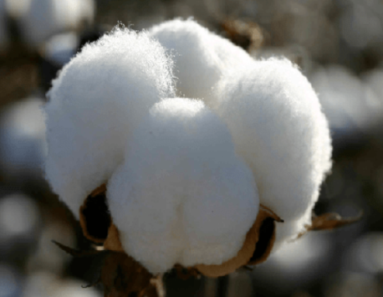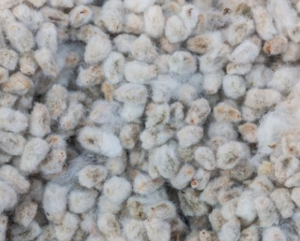

Figure:3.2Cotton Fibres*Figure:3.3* Cotton Fibre Comes From Cotton Seed

* + - 1. **FLAX FIBRE**

Flax (FIG:3.4), also known as common flax or linseed, is a [flowering plant](https://en.wikipedia.org/wiki/Flowering_plant), Linumusitatissimum, in the family [Linaceae](https://en.wikipedia.org/wiki/Linaceae). It is cultivated as a food and [fiber crop](https://en.wikipedia.org/wiki/Fiber_crop) in regions of the world with [temperate climates](https://en.wikipedia.org/wiki/Temperate_climate). Textiles made from flax are known in Western countries as [linen](https://en.wikipedia.org/wiki/Linen) and are traditionally used for bed sheets, underclothes, and table linen. Its oil is known as [linseed oil](https://en.wikipedia.org/wiki/Linseed_oil). In addition to referring to the plant, the word "flax" may refer to the unspun fibers of the flax plant. The plant species is known only as a cultivated plant and appears to have been domesticated just once from the wild species [Linumbienne](https://en.wikipedia.org/wiki/Linum_bienne), called pale flax. The plants called "flax" in New Zealand are, by contrast, members of the genus [Phormium](https://en.wikipedia.org/wiki/Phormium).Flax fiber is extracted from the bast beneath the surface of the stem of the flax plant. Flax fiber is soft, lustrous, and flexible; bundles of fiber have the appearance of blonde hair, hence the description "flaxen" hair. It is stronger than cotton fiber, but less elastic.A flax field in bloom in North Dakota

The use of flax fibers dates back tens of millennia linen, a refined textile made from flax fibers, was worn widely by Sumerian priests more than 4,000 years ago. Industrial-scale flax fiber processing existed in antiquity. A Bronze Age factory dedicated to flax processing was discovered in Euonymeia, Greece.

The best grades are used for fabrics such as damasks, lace, and sheeting. Coarser grades are used for the manufacturing of twine and rope, and historically, for canvas and webbing equipment.

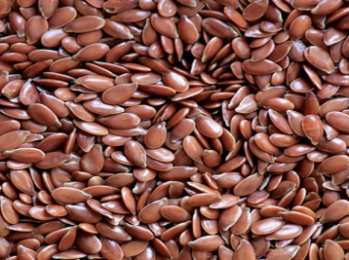Flax fiber is a raw material used in the high-quality paper industry for the use of printed banknotes, laboratory paper (blotting and filter), rolling paper for cigarettes, and tea bags. Flax mills for spinning flaxen yarn were invented by John Kendrew and Thomas Porthouse of Darlington, England, in 1787. New methods of processing flax have led to renewed interest in the use of flax as an industrial fiber.

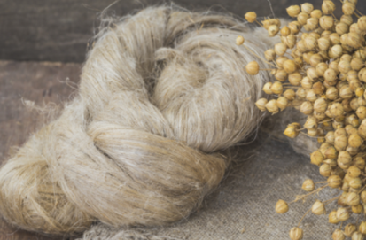

Figure:3.4Flax Seed Figure:3.5 Flax Fibre Comes From Flax Seed

* + - 1. **JUTE FIBRE**

Jute fibers (FIG:3.6)are totally biodegradable and recyclable materials, i.e., environmentally friendly materials. Jute fibers have good insulating properties for both of thermal and of acoustic energies with moderate moisture regain and no [skin irritations](https://www.sciencedirect.com/topics/engineering/skin-irritation) [34–39]. The current annual worldwide production of jute fiber is about 3.2 million tons and used for various applications. Bag cloth industry is the biggest consumer of jute fibers available in the markets. Jute bags have gained an advantage as being an eco-friendly option instead of both of nonbiodegradable poly bags that are made from petroleum and paper bags that require large quantities of wood. A huge amount of these jute fibers is wasted and is gone to landfill every year, either in the form of slivers resulted from manufacturing of jute cloth or in the form of used cloths after the end-of-life of the jute bags.Therefore, several attempts were carried out in our previous research [40–44] to use the above-mentioned valuable properties of jute fibers, to reuse the wasted jute slivers, to recycle the end-of-life jute bags for fabricating valuable jute/polymer composites, and sandwich jute composites. The jute sandwich composite structures were fabricated by attaching two thin but stiff skins made from [GFRP](https://www.sciencedirect.com/topics/engineering/fiber-reinforced-polymer) laminates to a lightweight but thick core made of jute mat. The overall process and some potential applications for the jute-reinforced polymer matrix composites and sandwich composites with thick jute mat as light core and thin GFRP laminates as stiff skins . These [natural fiber](https://www.sciencedirect.com/topics/engineering/natural-fibre) composites can be introduced for appropriate applications such as barrier walls against the thermal and acoustic energies for interior construction, lightweight panels for furniture construction, and housings for electronic equipment.Jute fiber is produced from plants in the genus Corchorus, family Malvaceae. Jute is a lignocellulosic fiber that is partially a textile fiber and partially wood. It falls into the bast fiber category (fiber collected from bast or skin of the plant). The chemical composition of jute fiber includes cellulose (64.4%), hemicellulose (12%), pectin (0.2%), lignin (11.8%), water soluble (1.1%), wax (0.5%), and water (10%). Jute fiber consists of several cells. These cells are formed out of crystalline microfibrils based on cellulose, which are connected to a complete layer by amorphous lignin and hemicellulose. Multiples of such cellulose and lignin/hemicellulose layers in one primary and three secondary cell walls stick together to form a multiple layer composite. These cell walls differ in their composition (ratio between cellulose and lignin/hemicellulose) and in the orientation of the cellulose microfibrils.

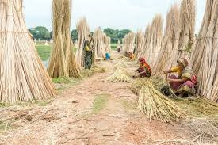

Figure 3.6 Jute Fibre

**3.2.1.4 BAMBOO FIBRE**

Bamboos are evergreen perennial flowering plants in the subfamily bambusoideae of the grass family. The word "bamboo" comes from the Dutch or Portuguese languages, which probably borrowed it from Malay.Bamboo is one of the fastest growing plants in the world, due to a unique rhizome dependent system. Certain species of bamboo can grow 910 mm (36 in) within a 24-hour period, at a rate of almost 40 mm (1 1⁄2 in) an hour (a growth around 1 mm every 90 seconds, or 1 inch every 40 minutes).Giant bamboos are the largest members of the grass family.

As a fibre, bamboo is a natural cellulosic regenerated biodegradable environment friendly textile material. Not only a green fibre but it has also inherent property of anti- bacterial and UV protective property, which makes it a unique ecofriendly textile material in 21st century. There are two manufacturing methods of bamboo fibres:

* Chemical Process
* Mechanical Process

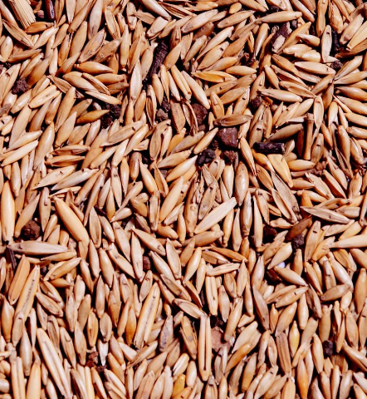Depending upon the type of fabric bamboo fibre(FIG:3.7)can be produce two different chemical methods. Majority of the bamboo fibres are produced by viscose rayon processing method. Which is cheap to produce but it has some environmental downside. Actually this method is regenerated or semi synthetic fibre processing method.

Figure 3.7 Bamboo Seed

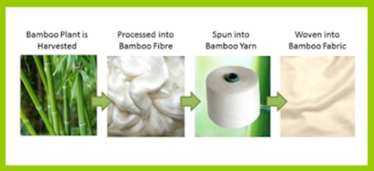

Figure 3.8 Bamboo Fibre Making Process

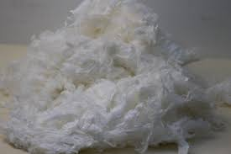

Figure 3.9 Bamboo Fibre

**3.2.1.5 BANANA FIBRE**

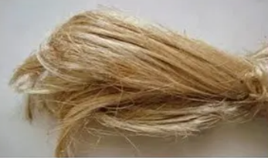Banana plant or plantain plant not only gives the delicious fruit but it also provides [textile fiber](https://textilelearner.net/difference-between-natural-fiber-and-man-made-fiber/), the banana fiber. Banana fiber (FIG:3.9 ) is natural fiber. It is a plant fibre. Natural Fibre present important advantages such as low density, appropriate stiffness and mechanical properties and high disposability and renewability. Moreover, they are recyclable and biodegradable. There has been lot of research on use of natural fibres in reinforcements. Banana fibre, a ligno-cellulosic fibre, obtained from the pseudo-stem of banana plant (Musa sepientum), is a bastfibre with relatively good mechanical properties. Banana plant is a large perennial herb with leaf sheaths that form pseudo stem. Its height can be 10-40 feet (3.0-12.2 meters) surrounding with 8-12 large leaves. The leaves are up to 9 feet long and 2 feet wide (2.7 meters and 0.61 meter). Banana plant is available throughout Thailand and Southeast Asian, India, Bangladesh, Indonesia, Malaysia, Philippines, Hawaii, and some Pacific islands.

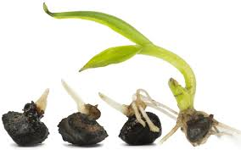

Figure 3.10 Banana Seed Figure 3.11 Banana fibre comes from banana seed

**3.2.2 SYNTHETIC FIBRE**

Synthetic fibres are man-made fibres, most of them are prepared from raw material petroleum called petrochemicals. All fabrics are obtained from fibres, while fibres are obtained from artificial or man-made sources. They consist of a small unit or a polymer which is made from many repeating units known as monomers. Semi-synthetic fibres derive from naturally-occurring fibres through a chemical process. The naturally occurring fibre is harvested, broken down, and then reconstructed. This is usually done using cellulose. Cellulose is a component that is abundant in plants. This cellulose is extracted from the plants, made soluble, and then spun into [fibre](https://www.toppr.com/guides/chemistry/synthetic-fibres-and-plastics/introduction-to-fibres/).

## Advantages of Synthetic Fibres

* Synthetic fibers have good elasticity.
* They don’t wrinkle up easily.
* Fabrics made from these fibres are less expensive, durable and readilyavailable in comparison to natural fibers.
* Synthetic fibers can handle the heavy load without breaking.
* They don’t shrink.
* Synthetic fibers blend well with other fibres.
* They’re very absorbent.

## Disadvantages of Synthetic Fibres

* Synthetic fibers require attention while ironing since they tend to melt away easily.
* Most of these fibres absorb very little. So, they stick to the body while sweating on hot summer days. Thus, making it uncomfortable to wear during such days.
* Synthetic fibers are prone to catch fire very easily.
* These fibres are non-biodegradable.

**3.2.2.1 TYPES OF SYNTHETIC FIBRES**

* **CARBON**
* **GLASS**

**CARBON**

Carbon fiber-reinforced plastics (CFRP) bring together the qualities and performance properties of carbon fiber (FIG:3.12) with the polymer material they are reinforcing. Printability and ease of use of a standard thermoplastic like PLA, ABS, or PET gains superior performance properties by including carbon fiber content. Chopped fibers are mostly used for industrial production and also 3D printing. These carbon fibers come as a "filler" material in thermoplastic materials for injection molding or as carbon fiber filaments to use in 3D printers. They can be processed like any other thermoplastic material. But they have extra requirements which will be explained later on.

Industrial environments often demand specific mechanical properties and finely tuned precision. Fortunately, by bringing together the capabilities of a high-strength material and the many advantages of additive manufacturing, carbon fiber 3D printing offers exceptional dimensional stability in strong, stiff parts with a fine surface finish and a high heat deflection temperature - ideal for functional, high-performance applications. With 3D printing moving ever deeper into end-use production, the ability to manufacture both parts and tooling using carbon fiber filaments is increasing in demand. Whether using these materials in molds, jigs, fixtures, tooling or high-performance race cars, specialty aerospace equipment, or professional cycling equipment, carbon fiber 3D printer filament enables you to create the high-strength parts you need. Of course, as a relatively new offering in the manufacturing industry, carbon fiber 3D printing may have many pros, but it's also worth being aware of the printing requirements before you get started.

Figure 3.12 Made with Carbon Fibre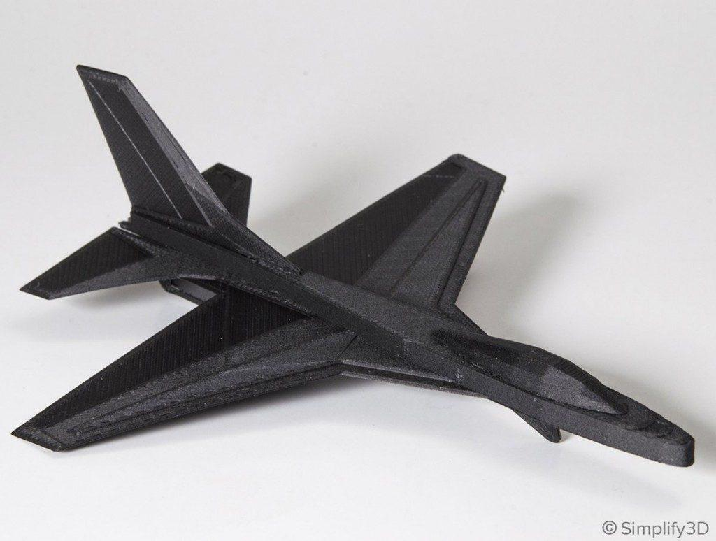

**GLASS**

Fiberglass (FIG:3.13)is a robust reinforcement option that has a bit more flex and energy return to it than carbon fiber. It's best used in intermittent loading conditions, and bends until eventual fracture. Fiberglass is a great general-use fiber for when you need sturdy parts, and it is the most cost-effective reinforcement option.

RIZE, Inc. announced immediate availability of RIZIUM Glass Fiber (GF), a composite 3D printing material with the high-dimensional stability and high stiffness for strength required for printing large parts. This material is suitable for full-color parts, and the stability to support parts with complex geometries that often can warp. It can be used in life sciences, communications, and branding applications that need life-like color in durable parts.Available on RIZE’s entire suite of 3D printers including those from RIZIUM Alliance industry partners, RIZIUM Glass Fiber is based on RIZE’s cyclic olefin-based matrix that does not release emissions at extrusion temperatures, and has low moisture absorption, and high chemical resistance. The material works with Augmented Polymer Deposition (APD) — a digital material technology that lets polymer material combine with functional inks to create new material properties. RIZIUM GF is stable over large build volumes. RIZIUM Glass Fiber also has obtained UL GREENGUARD Certification on the XRIZE full-color composite 3D printing platform, confirming it is safe to be used in offices/schools/hospitals and any enclosed spaces. The new material expands the portfolio of the RIZIUM Alliance, where other 3D printing industry partners can implement safer, sustainable, reyclable 3D printing on a variety of platforms, such as the RIZE 2XC.

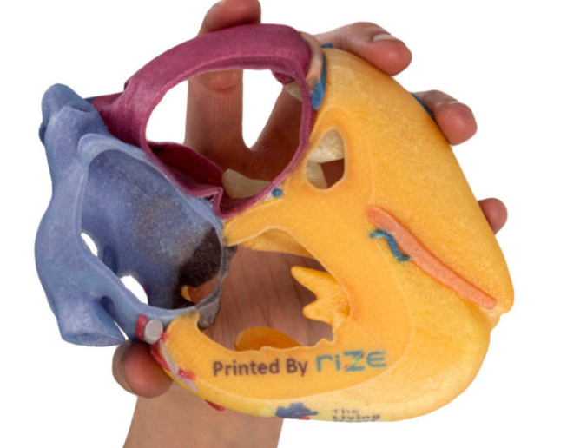

Figure3.13 Made with Glass Fibre

**CHAPTER-4**

**PREPARATION OF FILAMENT**

**4.1PREPARATION PROCESS**

### **Step 1: Separation**

First, the fibres from the banana stems and peels are separated from their non-usable components. Various techniques are used to attain these fibres, which involve soaking the peels in a chemical substance or water to soften and separate the fibres.

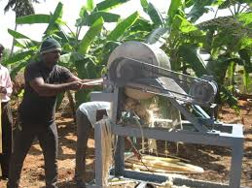

### **Step 2: Drying and Bunching**

Once the fibres are separated, they are bunched together and left to dry. After this step, the outer and inner fibres are kept together, as it is hard to separate them when they are wet.

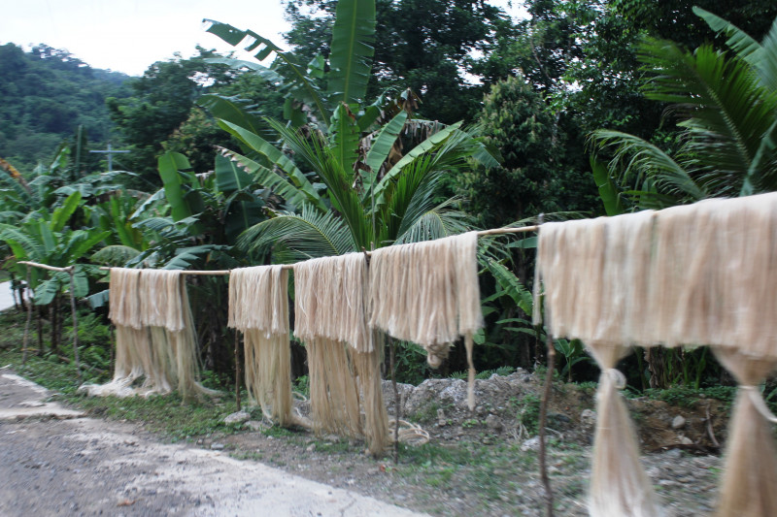

### **Step 3: Grouping**

Once the fibres are dry, it is separated into various groups based on quality. Group A contains the best fabrics and is used for silk applications. Some manufacturers only have two groups, whereas others produce different grades of banana fibre.

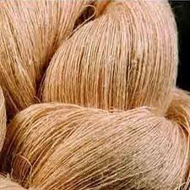

### **Step 4: Spinning and Weaving**

Finally, the separated fibres are spun into yarn. It is dyed, treated and then woven into accessories, clothes, decor items, or industrial products. This process was earlier handmade, making it harder to process on a larger scale. It is where machines come in.

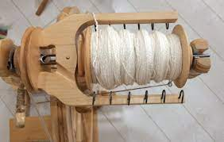 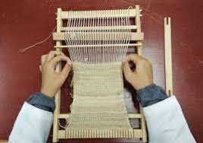

***SPINNING WEAVING***

**Types Of Banana Fibre**

**1. Outer peel banana fibre**: This course and rough fibre has been used for centuries in industrial applications. It is also perfect for ropes, mats, and thick outerwear and garments.

**2. Inner peel banana fibre**: This banana fabric is super soft, just like silk. It is reasonably delicate and is very expensive to produce.

**3. Banana silk**: This fabric is not a banana fibre and silk mixture. It is just another term for the inner peel banana fibre, which is similar to the properties of silk.

**4. Banana cotton**: The high-grade fabric from the outer banana peel is also called banana cotton. It has a texture like cotton, and the two have many other similarities.

**4.3 FIBRE IN POWDER STATE**

Alluvial sandy loam, Clay Loamy soils are best Suited for Jute Production ,C. capsularisjute (FIG:4.1 ) can grow even in standing water especially towards the latter part of its growth,C. olitorius jute (FIG:4.2 ) will not thrive in standing water. The later is more drought resistant and is therefore grown on lighter soils

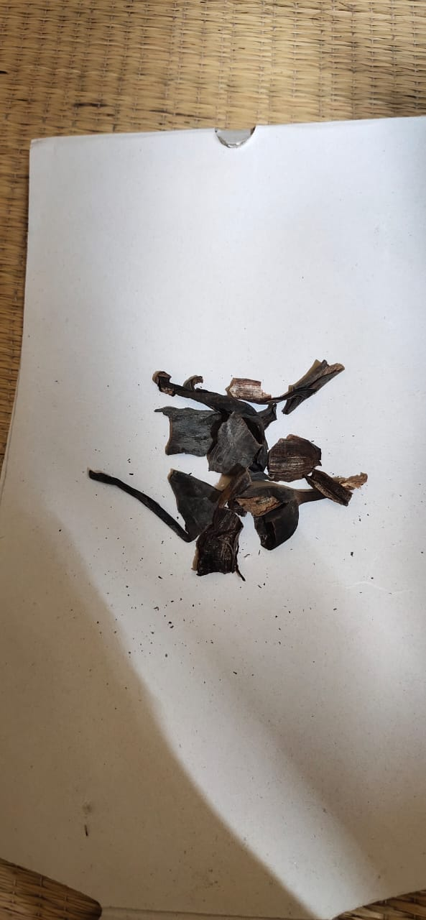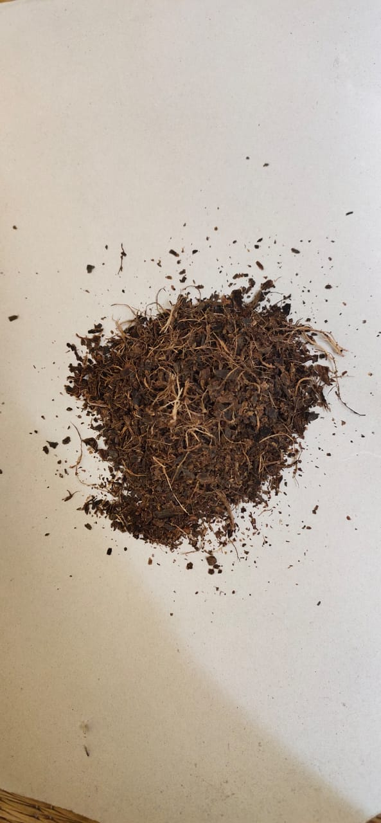 Figure 4.1 Banana shell Figure 4.2 Banana powder processing

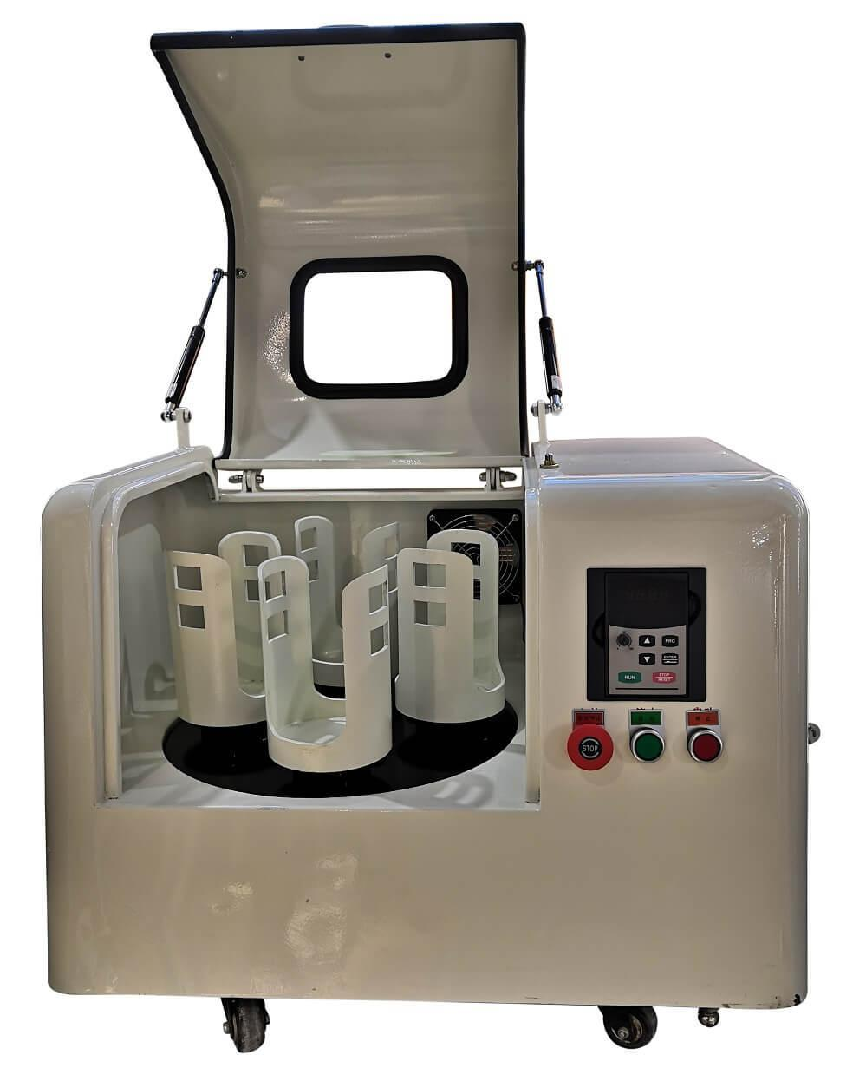After we getting Banana seed from banana plant it have to be converted into Fine Powder Form Fibre can Convert into powder form by Using Ball Milling (FIG:4.2.1 ) Curse it with ball Milling Until it converts into Fine Powder Form

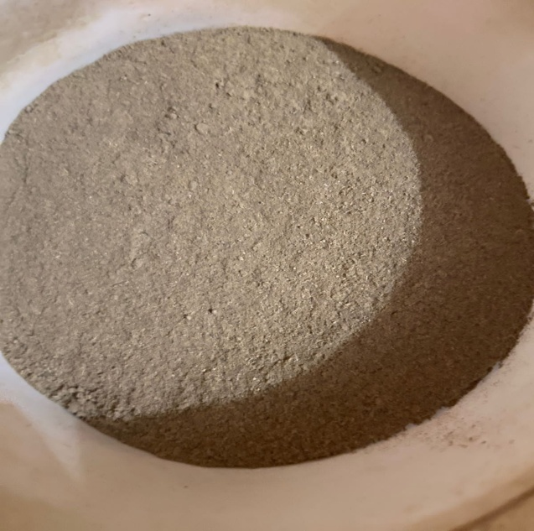 Figure 4.3 Ball milling

Figure 4.4 Banana Powder

**4.4 Advantages Of Using Banana Fibre**

While there are numerous benefits of using **banana fibre**, here are its three main advantages:

* **Low Impact On Soil Health:** Unlike cotton, which needs tilling to re-fertilize the soil, banana trees re-grow in the same place. It also does not require additional water, land, or fertilizers, and the roots are strong enough to hold the soil in place, thus preventing landslides. Its low energy, low water consumption, and chemical-free fibre production has minimal impact.
* **Non-Toxic: Banana fibres** :Do not use or need genetically modified crops. Thus, they provide a sustainable livelihood for the farmers. Banana fabrics also do not contain dyes – so no chemicals can contaminate the local water supplies. It is safe for the wearer and does not cause any irritation or allergies.
* **No Wastage:** Banana fibre is made from parts of the banana tree and banana peel that is discarded if not put to use. Creating something valuable from anything that otherwise goes to waste makes **banana fibre** one of the best alternatives to several other synthetic and natural fibres.

**DISADVANTAGES OF BANANA FIBRE:**

Banana fibre has major drawbacks in composite production, such as low interfacial bond strength between fibre and matrix when compared with synthetic fibre.

**TABLE:4.1 FIBRES TENSILE STRENGTH AND MELTING TEMPERATURE**

|  |  |  |
| --- | --- | --- |
| **Fibre** | **TENSILE STRENGTH**  **(MPa)** | **MELTING TEMPERATURE**  **℃** |
| ABACA | 621.5 | 161-171 |
| BAMBOO | 566 | 154 |
| BANANA | 721.5 | 62 |
| COIR | 175 | 80 - 120 |
| COTTON | 442 | 149-246 |
| FLAX | 689 | 190 |
| HEMP | 845 | 150-200 |
| JUTE | 480 | 160-260 |
| KENAF | 612.5 | 160 |
| PINEAPPLE | 898.5 | 165-166 |
| RAMIE | 669 | 165 |
| SISAL | 681 | 180 |

From The Above Mentioned Table We Selected Jute As A Natural Fibre To Mix With Pla To Get A Filament

**4.4 MATERIALS USED**

* **PLA**
* **BANANA FIBRE (NATURAL FIBRE)**

**4.4.1 PLA**

Polylactic acid, also known as PLA, is a thermoplastic monomer derived from renewable, organic sources such as corn starch or sugar cane. Using biomass resources makes PLA production different from most plastics, which are produced using fossil fuels through the distillation and polymerization of petroleum.

* + 1. **JUTE FIBRE**

Banana fibre is a type of plant fibre which is widely known for its ability to be spun into strong and coarse threads. Individual jute fibres are known to be soft, long, and shiny in nature. The plants belonging to the genus Corchorus are believed to be the primary producers of this fibre.

**4.5 MAIN MOTIVE TO PREPARE A FILAMENT WITH NATURAL FIBRE**

* In Industry, many components are manufactured in Additive Machining. But the materials for AM are mostly Polymers.
* Polymer and Polymer Composite are mostly made up of Non Biodegradable and it may leads the Environmental Problems
* Most of the Polymer filaments are fabricated by the Extruder Process
* So our project of main themes is to reduce the non biodegradable components.

**4.6 PREPARATION OF FILAMENT**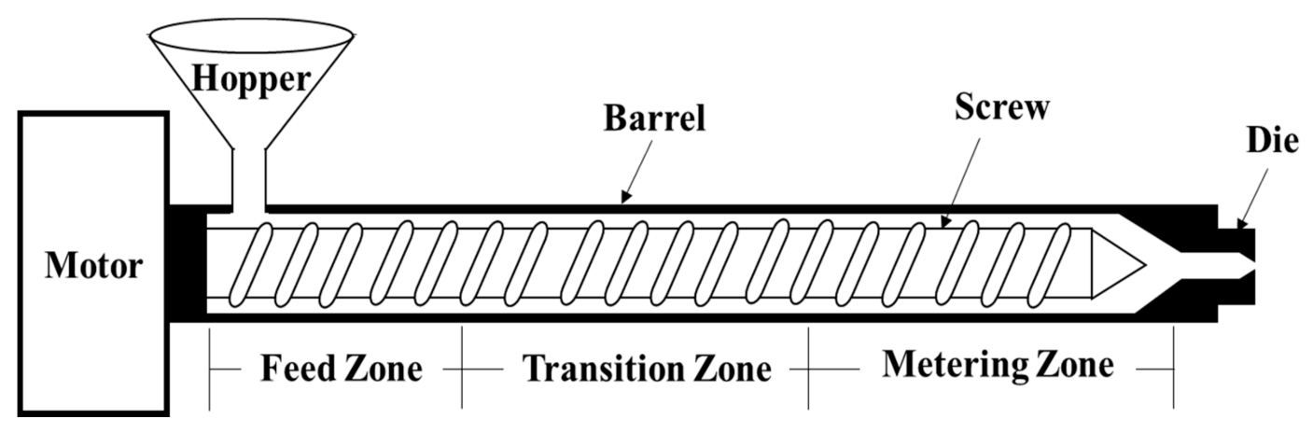

Figure 4.5 **SCHEMATIC DIAGRAM OF TWIN EXTRUDER**

Nozzle Diameter = 2 mm to 1.75 mm

Temperature in Barrel is 160℃, 180℃, 200℃.

**PROCESS**

* Pour the materials Both PLA and Banana fibre into the hopper
* Screw Helps to Mix both the Materials
* The barrel has three zones: feed zone, transition zone, and metering zone
* The raw materials soften into the feed zone, plasticized in the transition zone, and completely melted in the metering zone.
* Motor at the left corner helps to rotate the screw
* The temperatures at different zones are selected based on the input materials
* After passing through the die, the extruded materials pass through a cooling zone. The quality of filament is significantly affected by the rate of cooling. Different cooling techniques such as water bath and cold air gun are used for filaments
* After manufacturing if its is not cooled Breakage of Filament may occurs
* Molten Speed May Vary Depends Upon the Output of Filament Actual Twin Extruder is Shown in (FIG: 4.7 )

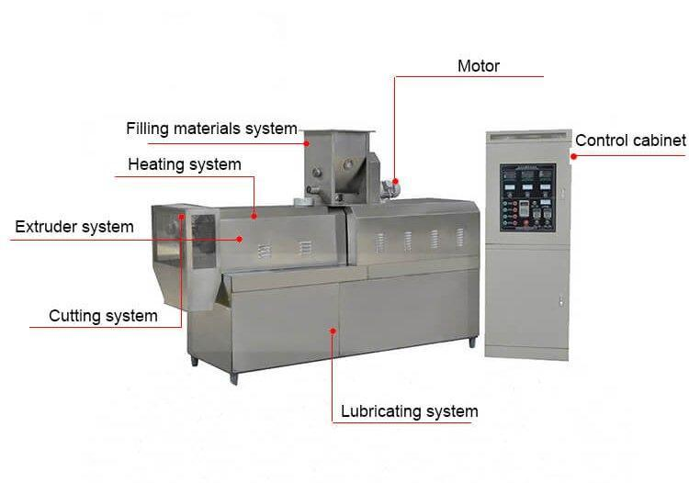

Figure 4.6 **TWIN EXTRUDER**

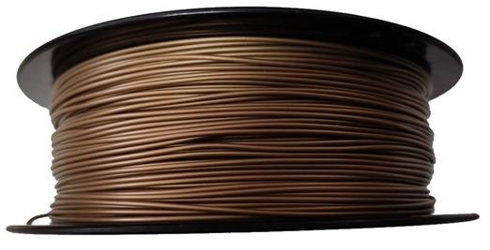

Figure 4.7 Filament after Prepared with Natural Fibre and PLA

**CHAPTER-5**

**CONCLUSION**

One of the biggest challenges for adopting additive manufacturing as a commercial production method is the availability of suitable materials. The requirements such as mechanical properties, thermal conductivity, electrical conductivity for real-world applications may not be fulfilled by parts produced from the FFF process alone. Polymer and Polymer Composite are mostly made up of non-Biodegradable and it may lead the Environmental Problems. Most of the Polymer filaments are fabricated by the Extruder Process.

**5.1 Filament is getting stuck or tangled**

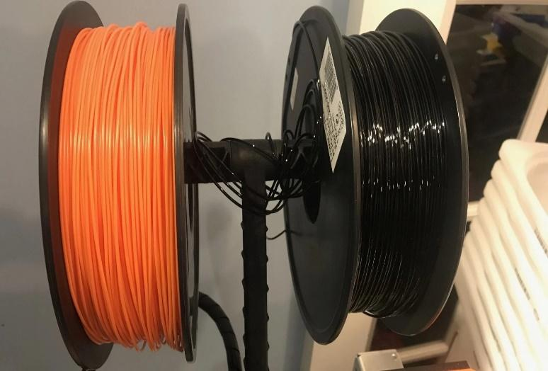The first thing you should check is the spool of plastic that is feeding into your printer. You need to make sure that this spool is able to rotate freely and that the plastic is easily being unwound from the spool. If the filament becomes tangled, or the spool has too much resistance to spin freely, it will impact how evenly the

Figure 5.1Filament is getting stuck or tangled

evenly the filament is extruded through the nozzle. If your printer includes a Bowden tube (a small hollow tube that the filament is routed through), you should also check to make sure that the filament can easily move through this tube without too much resistance. If there is too much resistance in the tube, you may want to try cleaning the tube or applying some lubrication inside the tube.

**5.2 Clogged Extruder**

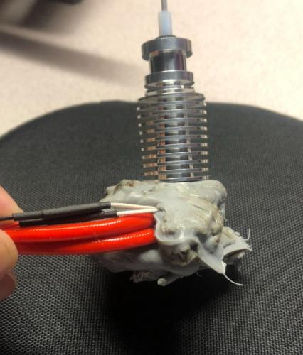If the filament is not tangled and can easily be pulled into the extruder, then the next thing to check is the nozzle itself. It is possible that there is some small debris or foreign plastic inside the nozzle that is preventing proper extrusion. An easy way to check this is to use Simplify3D’s machine control panel to manually extrude some plastic from the nozzle. Watch to make sure that the plastic is extruding evenly and consistently. If you notice problems, you may need to clean the nozzle. Please consult your manufacturer for instructions on how to properly clean the inside of the nozzle.

Figure 5.2 Clogged Extruder

**5.3 Very low layer height**

If the filament is spinning freely and the extruder is not clogged, as Shown in Fig 6.3 & 6.4 it may be useful to check a few settings within Simplify3D. For example, if you are trying to print at an extremely low layer height, such as 0.01mm, there is very little room for the plastic to exit the nozzle. This gap below the nozzle is only 0.01mm tall, which means that the plastic may have a difficult time exiting the extruder. Double check to make sure you are using a reasonable layer height for your printer. You can view this setting by clicking “Edit Process Settings” and selecting the Layer tab. If you are printing at a very small layer 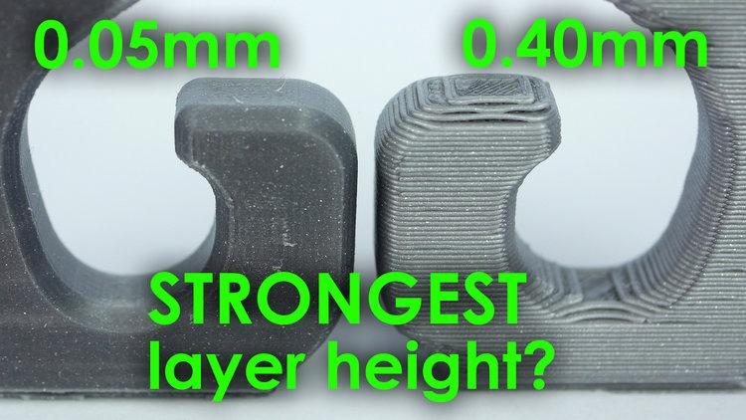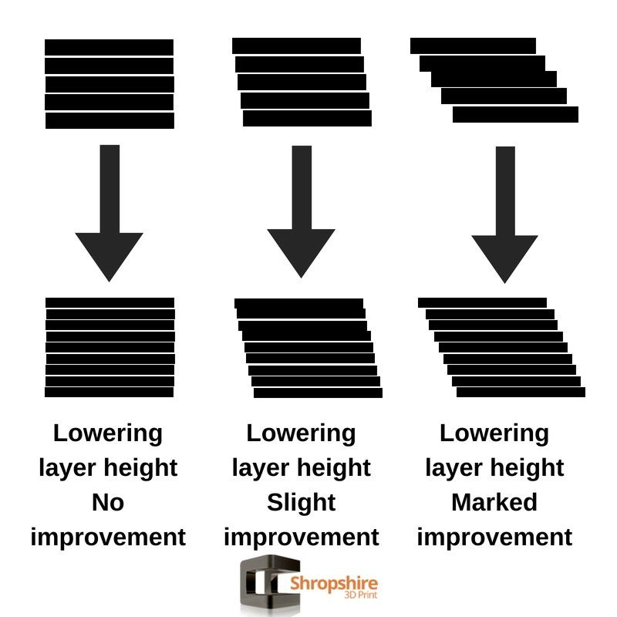height, try increasing the value to see if the problem goes away.

Figure 5.3 Very low layer height Figure 5.4 Very low layer height

**5.4 Incorrect extrusion width**

Another setting to check within Simplify3D is the extrusion width that you have specified for your extruder. You can find this setting by clicking “Edit Process Settings” and going to the Extruder tab. Each extruder can have its own unique extrusion width, so make sure you select the appropriate extruder from the list of the left to view the settings for that specific extruder. If you extrusion width is significantly smaller than your nozzle diameter, this may cause extrusion issues. As a general rule of thumb, the extrusion width should be within 100-150% of the nozzle diameter. If your extrusion width is far below the nozzle diameter (for example, a 0.2mm extrusion width for a 0.4mm nozzle), then your extruder won’t 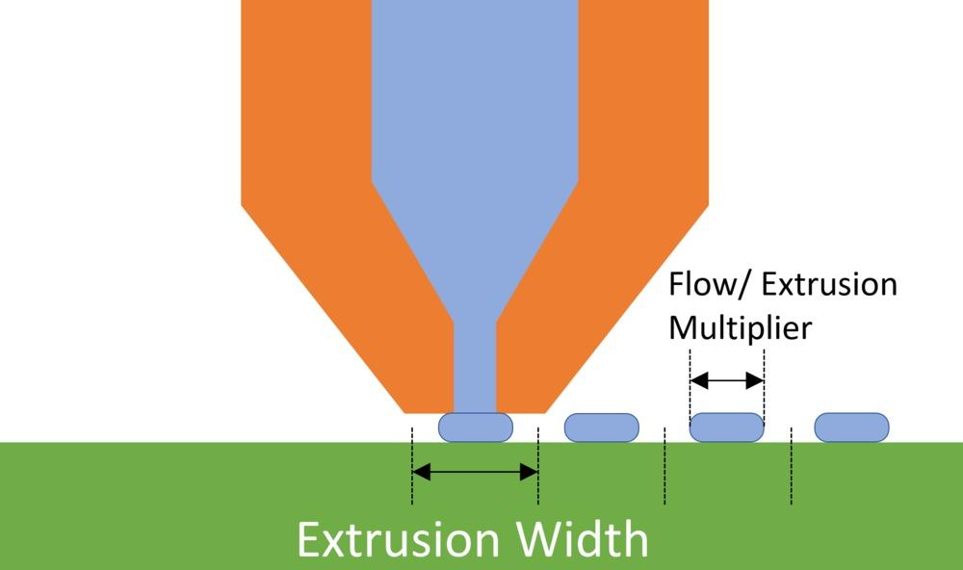be able to push a consistent flow of filament.as Shown in Fig 6.5

Figure 5.5 Incorrect extrusion width

**5.5 Poor quality filament**

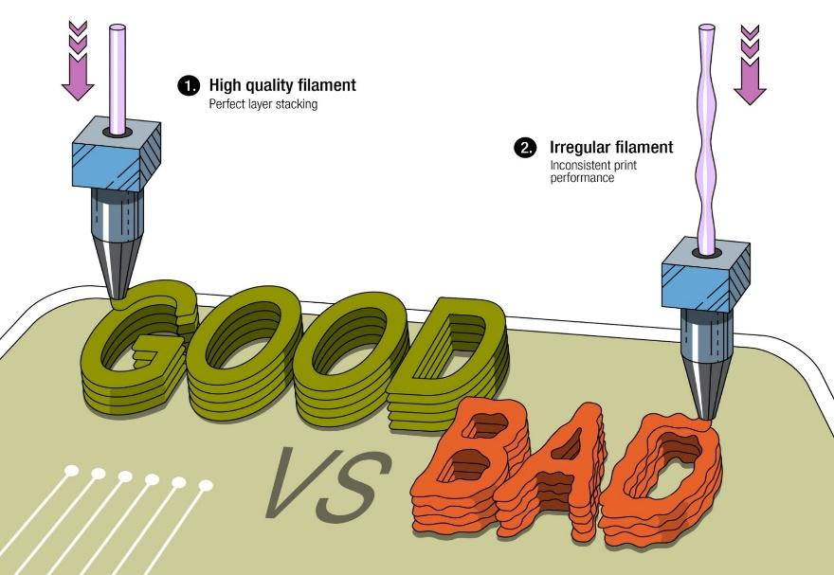One of the most common causes of inconsistent extrusion that we have not mentioned yet is the quality of the filament that you are printing with. Low-quality filament may contain extra additives that impact the consistency of the plastic. Others may have an inconsistent filament diameter, which will also cause inconsistent extrusion. Finally, many plastics also have a tendency to degrade over time. For example, PLA tends to absorb moisture from the air, and over time, this will cause the print quality to degrade. This is why many spools of plastic include a desiccant in the packaging to help remove any moisture from the spool. If you think your filament may be at fault, try swapping the spool for a new, unopened, high-quality spool to see if the problem goes away.

Figure 5.6 Poor quality filament

**5.6 Mechanical extruder issues**

If you have verified everything above and are still having problems with inconsistent extrusion, then you may want to check for mechanical issues with your extruder. For example, many extruders use a drive gear with sharp teeth that bite into the filament. This allows the extruder to move the filament back and forth easily. These extruders also typically include an adjustment that changes how hard the drive gear is pressed into the filament. If this setting is too loose, the drive gear teeth won’t cut far enough into the filament, which impacts the extruder’s ability to accurately control the position of the filament. Check with your manufacturer to see if your printer has a similar adjustment.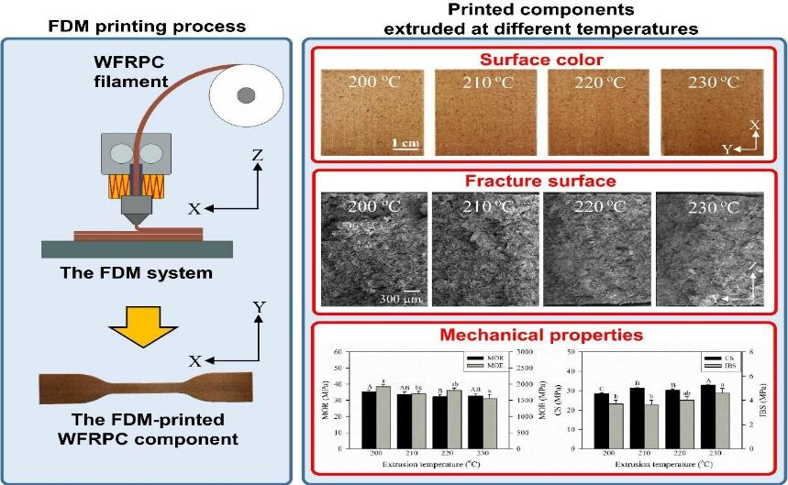

Figure 5.7 Mechanical extruder issues

The above mentioned few problems are rectified in the making of PLA and Natural Fiber mixing filament.

**REFERENCES**

1. Salman Pervaiz . (2021) 3d Printing Of Fiber-Reinforced Plastic Composites Using Fused Deposition ModelingVol 14,Iss 16, Pg 171-176
2. RupakDua, (2021) Applications Of 3d-Printed Peek Via Fused Filament Fabrication,MdpiPolymers,MdpiMaterials,Vol 13, Iss 22,Pg 426-431
3. Balwant Singh,(2020)Polymer Matrix CompositeIn 3d Printing,MaterialstodayProceedings,Vol 33,Part 3,Pg 1562-1567
4. R Surya Teja,(2022) 3d Printing Of Complex Structures: Case Study Of Eiffel Tower, MaterialstodayProceedings,Vol 76,Part 4,Pg 640-646
5. NurulHusnaMohdYusoff,(2023) Optimization Strategies And Emerging Application Of Functionalized 3d-Printed Materials In Water Treatment,Journal Of Water Process Engineering,Vol 51**,**Pg 107-122
6. A Mantelli, A Romani, R Suriano, M Diani, M Colledani 2021. UV assisted 3D printing of polymer composites from thermally and mechanically recycled carbon fibers. MDPI, Polymers, Volume 13.
7. AD Valino, JRC Dizon, AH Espera Jr., Q chen 2019. Advances in 3D printing of thermoplastic polymer composites and nanocomposites. Elsevier, Progress in Polymer Science, Volume 98.
8. AN Dickson, HM Abourayana, DP Dowling 2020. 3D printing of fiber reinforced thermoplastic composites using fused filament fabrication: A review. MDPI, Polymers, Volume 12.
9. D Yang, KWu, Y Sheng 2017. A particle element approach for modeling the 3D printing process of fiber reinforced polymer composites. MDPI, Journal of Manufacturing and Material Process, Volume 1.
10. EdaHazalTumer, HusnuYildrim Erbil 29th Mar 2021. Extrusion based 3D printing application of PLA composites: A review. MDPI, Coatings, Volume 11.
11. Francis Dantas, Kevin Couling and Gregory J. Gibbons 2020. Long-fiber reinforced polymer composites by 3D printing: influence of nature of reinforcement and processing parameters on mechanical performance. SpringerOpen, Functional Composite Materials, Volume 7.
12. FrantišekBárnik, Milan Vaško, Milan Sága, MariánHandrik, AlžbetaSapietová 2018. Mechanical properties of structures produced by 3D printing from composite materials. EDP Sciences, MATEC web of conferences, Volume 254.
13. Haoqi Zhang, Jiang Wu, Colin Robert, Conchur MO Bradaigh, Dongmin Yang 2022. 3D printing and epoxy infusion treatment of curved continuous carbon fiber reinforced dual polymer composites. Elsevier, Composites Part B : Engineering, Volume 234.
14. JP Lewicki, JN Rodriguez, C Zhu, MA Worsley 2017. 3D printing of meso-structurally ordered carbon fiber/ polymer composites with unprecedented orthotropic physical properties. Scientific Reports, Scientific Reports, Volume 7.
15. KatarzynaBryll, ElżbietaPiesowicz, PawełSzymański, WojciechŚlączka and MarekPijanowski 2018. Polymer Composite Manufacturing by FDM 3D Printing Technology. EDP Sciences, MATEC web of conferences, Volume 237.
16. LaythMohammed, M. N. M. Ansari, Grace Pua, Mohammad Jawaid, Saiful Islam 30th Aug 2015. A Review on Natural Fiber Reinforced Polymer Composite and Its Applications. Hindawi, International Journal of Polymer Sciences, Volume 2015.
17. Mario Piedrahita Bello, Jose Elias Cervera, RemiCourson, Gabor Molnar, Laurent Malaquin, Christophe Thibault, Bertrand Tondu, Lionel Salmon, AzzedineBousseksou 2020. 4D printing with spin crossover polymer composites. Publishing, Journals of Material Chemistry C.
18. Masahito Ueda, Yuuki Watanabe, Yoichi Mukai, Nobuhisa Katsumata 2021. 3D printing of locally bendable short carbon fiber reinforced polymer composites. Kingfa, Advanced Industrial and Engineering Polymer Research, Volume 4.
19. Mateusz Galeja, AleksanderHejna, Paulina Kosmela 9th Jan 2020. Static and Dynamic mechanical properties of 3D printing ABS as a function of raster angle. MDPI, Materials, Volume 13.